# 

**TECHNICAL REPORT (PART B)**

**COVER PAGE**

**DRAFT**

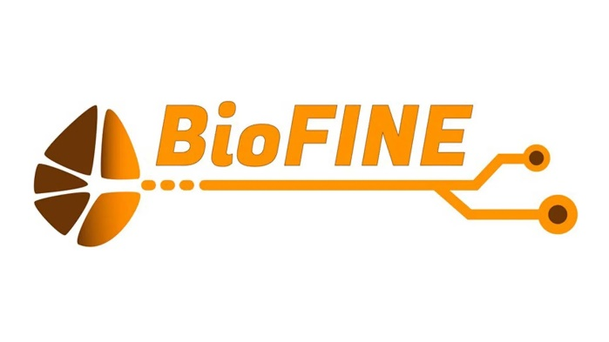

|  |  |
| --- | --- |
| **PROJECT** | |
| **Project number:** | 101099366 |
| **Project name:** | BioFunctional IntraNeural Electrodes |
| **Project acronym:** | BioFine |

|  |  |
| --- | --- |
| **REPORTING PERIOD** | |
| **RP number:** | *[*1*]* |
| **Duration**: | from 01/04/2023 to 31/09/2024 |

Contents

1. Explanation of the work carried out and Overview of the progress 3

1.1 Objectives 3

1.2 Explanation of the work carried out per WP 6

1.3 Impact 35

1.4 EIC Specific Activities and other exploitation/regulatory services 35

1.5 EIC Portfolio Activities and/or activities with the EIC PM 35

1.6 Update of the plan for exploitation and dissemination of results (if applicable) 36

2. Follow-up of recommendations and comments from previous review(s) (if applicable) 36

4. Open science 36

5. Deviations from Annex 1 and Annex 2 (if applicable) 36

5.1 Tasks/objectives 36

5.2 Use of resources 38

#@PER-REP-HE@#

#@PRO-GRE-PG@# [This document is tagged. Do not delete the tags; they are needed for the processing.]

## 1. Explanation of the work carried out and Overview of the progress

### 1.1 Objectives

In the table below, the specific objectives as described in section 1.3 of the Description of the Action are described together with the work carried out related to each objective during the first reporting period (April 1st 2023 to March 31st 2024). Thereafter the work carried out relating to each task which have started is explained in the corresponding work package.

|  |
| --- |
| **Objective 1: Improving functionality of intraneural interfaces** by increasing the number of electrodes from a few dozen to a hundred. This will require a targeted effort both on the implantable high-channel connectors and in the implementation of new lithographic techniques such as e-beam to minimize volume occupied by connection lines. Furthermore, we will combine micro- and nanopatterning of electrodes to maximize their electrochemical efficiency. |
| **Work carried out related to objective No.1:**   * **WP1:** In RP1 we identified the guidelines, regulations and standards to follow during the development and fabrication of the implant (REACH, RoHS, MDR, ISO 10993).WP1 focused on the objectives of managing the requirements for the entire implant regarding the miniaturization of the interconnection, in line with the contributed advances in miniaturization approaches of Chalmers on the electrode end of the pipeline. This involves an assessment of available and plausible approaches for adapter technologies on different substrate materials and several manufacturing methods. Furthermore, the analysis of the manufactured electrodes included the design of experiments evaluating crosstalk between connection lines to quantify the limitations of miniaturization within a statistically significant framework, which defines the minimum sample size for the rejection of a null hypothesis. In addition to this, further considerations are also analysed and presented regarding the compatibility of the interconnection adapter and cable technologies available within the scope of this project. This involves the dimensions of the implant and its adaptability for small animal models. * Further work includes the management with project partners of the workflow to ensure the tracking of the implant parts to be transferred between the different locations, their storage requirements and the maintenance of minimal levels of errors due to variabilities in handling and/or processing conditions. * **WP2:** In RP1 we have focussed on novel methods increasing the achievable patterning resolution in the flexible probe manufacturing process. In line with the DoA we have explored e-beam direct writing of resist patterns, which allowed us to reach a lower resolution for metal lines of 0.4 µm, close to the project target. Furthermore, we introduced laser writing as an alternative patterning step, where metalized lines down to 1 µm wide, with a pitch of 2 µm were possible, where we expect further improvement with optimization. We have developed a battery of test structures where we analyse the trade-offs between fine lines and sufficient conductivity, and furthermore can optimize etch and metallization steps for via structures. * **WP4:** In RP1 the first proposed design for the BioFINE intraneural electrodes has been defined, from the basis of previous designs and *in vivo* testing experience. * ***WP3, WP5:*** *Not applicable* |
| **Objective 2: Develop a surface modified platform** by which the surface of thin-film polyimide (PI) and of polydimethylsiloxane (PDMS) based implants can be decorated to reduce the FBR. We will immobilize bio-active molecules and macromolecules which are capable of bridging the biotic/abiotic interface and increase the likelihood that the implant is seamlessly interfaced with its surroundings. |
| **Work carried out related to objective No.2:**   * **WP2:** We have fabricated a diversity of PI test samples supporting chemical, biological and electrical tests of (1) the effectiveness of the modified surfaces to reduce inflammation and (2) how the modification process itself impacts the samples. For the biological tests dedicated samples have been prepared both for *in vitro* and *in vivo* tests. * **WP3:** A general strategy has been developed that enables the functionalization of PI towards the construction of bioactive films. This strategy is basically based on a first KOH treatment that partially hydrolyses the surface imide groups thereby leading to carboxylic moieties that can be subsequently functionalized. At this stage, the ROS scavenging molecular system TEMPO (2,2,6,6-tetramethylpiperidine-1-oxyl) has been incorporated on PI whereas the synthesis of strategic peptides and/or their fragments (laminin for instance) is ongoing and their incorporation onto PI will be achieved during the next two months. Studies on PDMS substrate will be started during the last year of the project, according to BioFINE Gannt Chart. * **WP4**: Compounds to be used on the surface of PI have been selected. Initial assays of these compounds to modulate the inflammatory response have been made first in *in vitro* models of activated macrophages, followed by *in vivo* studies with PI devices implanted in the nerve. * ***WP1, WP5:*** *Not applicable* |
| **Objective 3: Develop a surface modification add-on** to allow substances to be released into the surrounding tissue at predefined dosage. This way it will be possible to reduce the inflammatory response in the tissue specifically and locally, which will be important in particular to lower the acute inflammatory response (in response to insertion trauma) and avoid that the inflammation itself causes secondary trauma. |
| **Work carried out related to objective No.3:**   * **WP2:** The test samples prepared under point 2 are also serving for the exploration of this objective. * **WP3:** Following the general synthetic strategy, the corticosteroid dexamethasone (DEX) has been successfully incorporated on PI following a silane-based chemistry. Indeed, the direct incorporation of DEX on activated PI resulted in a poor dosage, likely too low to give a relevant therapeutic effect. This forces us to construct a 3D scaffold on the top of PI, in order to increase the drug loading which may reflect a more relevant therapeutic effect. Apart from DEX, we are currently investigating the possibility of introducing an inflammasome inhibitor, that has been reported to exert a significant reduction of the tissue inflammation. The idea is to build a synergic dual drug delivery system that delivers both the corticosteroid and the inflammasome inhibitor. * **WP4:** *In vitro* and *in vivo* initial studies have been performed with the first set of PI devices with anti-inflammatory compounds bound to the surface. * ***WP1, WP5:*** *Not applicable.* |
| **Objective 4: Optimize the design and assess in vivo the functionality of the newly enhanced nerve electrodes**. In addition, we aim to improve electrode-nerve integration and reduce scar tissue formation around intraneural electrodes by the individual or combined effect of locally released anti-inflammatory compounds and functionalized substrate surface. We will define the most effective strategies to enhance tissue integration, electrophysiological functionality and longevity of intraneural microelectrode arrays beyond the presently existing limitations. |
| **Work carried out related to objective No.4:**   * **WP2:** Based on the fabrication processes outlined in D2.1 we are designing the first generation of BioFINE implants that will have a substantially higher number of electrodes than seen for previous TIMEs or LIFEs, yet be both thinner and smaller than those preceding arrays. To support future optimization processes for generation 2 and beyond, we are outlining the first generation such that it includes electrodes spanning a size range seen with previous TIMEs (Ø 30-50 µm) and in addition clusters of electrodes that go below this size range (Ø 12-25 µm). With these we hope to explore *in vivo* which minimum electrode size that effectively can be used for recording as well as stimulation. * **WP4:** The first proposed design for the BioFINE intraneural electrodes has been defined. The electrophysiological setting for assessing the stimulation and recording properties of intraneural and extraneural electrodes has been optimized. * ***WP1, WP3, WP5****: Not applicable* |

### 1.2 Explanation of the work carried out per WP

#### **1.2.1 Work Package 1 - Implant design & interconnection**

**Work package overview**

|  |  |  |  |
| --- | --- | --- | --- |
| **Work package number** | WP1 | **Lead beneficiary** | ALU-FR |
| **Work package title** | Implant design & interconnection | | |
| **Start month** | 1 | **End month** | 36 |
| **Objectives:** | Development of a long-term stable peripheral nerve implant with (1) novel reliable high-channel count interconnection towards ultra-flexible foils, (2) high electrical insulation and low crosstalk assembly and packaging resulting in (3) miniaturized connection to cables and connectors for recording and stimulation | | |

**Summary of progress and work carried out (deliverables and achievements)**

|  |  |  |  |
| --- | --- | --- | --- |
| **Task** | **Progress** | **Partners** | **Summary of Deliverables and Achievements** |
| Task 1.1: System design and integration | Ongoing (M1-36) | **ALU-FR,** Unife, Chalmers, UAB | In D1.1, WP1 provided an overview of the regulations and regulatory bodies to be considered for material selection. An analysis of different assembly and interconnection methods was also presented, together with initial results and experimental plans. The role of WP1 in managing the target specifications with the partners extends to defining recommendations for handling/labelling/storing the samples and preparing them for transport along the manufacturing pipeline. Finally, in collaboration with WP2, an experimental setup and sample size recommendation for the study of surface modification effects on crosstalk was presented. |
| Task 1.2: Assembling strategies and methods | Ongoing (M1-18) | **ALU-FR,** Chalmers | D1.2 Showcasing strategies of available techniques - Gold-stud bumping is identified as the most viable interconnection technology for microfabricated thin-film flexible electrodes with high channel counts and the need of hybrid assembly. |
| Task 1.3: Insulation of high channel count packages | Ongoing (M6-36) | **ALU-FR,** Chalmers, Unife, UAB | D1.3 Crosstalk testing plan and execution in progress – The sample size was defined with the goal of obtaining statistically relevant/significant results. The setup and sample design were coordinated with WP2. (Figure WP1.3) |
| Task 1.4: Post explantation explant analysis | Not Started (M18-26) | **ALU-FR,** Chalmers, UAB | D1.4 Not yet applicable |

**Overview of tasks**

|  |  |
| --- | --- |
| **Task 1.1: System design and integration** | |
| Lead beneficiary | ALU-FR |
| Start-end month | M1-36 |
| Contributing partners | Unife, Chalmers, UAB |

* **Task summary/description**

Considering the future applications of this project would aim for human implantation, the requirements on selecting methods and materials that are accessible and permitted for human applications is necessary. To fulfil this aim, a review of the available legislations (such as REACH, RoHS, MDR) and regulatory bodies (ECHA) on material selection for use in medical applications has been performed. Regulatory standards such as the ISO 10993 have been reviewed for the extraction of testing methods, which would be implemented in future work in this project.

The management of the implant specifications w.r.t. size, number of channels, compatible methods of fabrication/assembly, and extending to handling, storage and transport conditions have been discussed with partners to meet consensus.

* **Progress of work**

Ongoing -Deliverable No. D1.1 (initial draft submitted on 31.03.24)

* **Work process in the task**

Communication with project partners is ongoing via e-mail and monthly virtual meetings. Planning and addressing the possible hurdles in the pipeline from fabrication of the samples to the final implant assembly is continuously coordinated with the project partners. Implant target specifications through overview of legal requirements and standards are included in the deliverable. Further, we assess the challenges posed by the increase in electrode channel count on the manufacturability of the implant, including considerations on the overall weight, size, use of multiplexer elements, and the number of cables needed.

Moreover, the handling requirements of the electrodes and the conditions they would undergo after fabrication/functionalization are presented for discussion with WP partners. Indications on recommended storage conditions are also included. Here we draw references from regulatory standards for material selection and testing methods for biocompatibility and long-term implantation, to remain on track with the future trajectory of human applications.

To ensure adequate tracking of the samples, batch numbers or probe IDs are recommended to be introduced in an indelible manner e.g. through etching or laser patterning directly on the samples. First design ideas are being developed to integrate a low channel count multiplexer on the interconnecting device for the generation 0 samples (elaborated in **Task 1.2**) with the purpose of reducing cable size. This proof of concept will establish new technologies to bridge the gap between microfabrication and assembling off-the-shelf components (e.g. multiplexers) on the connector base substrate (silicon or alumina). This would also determine the number of channels to be finally implemented, depending on the selected size of multiplexer.

* **Summary of results**

An analysis of cost-effective prototyping/manufacturing has shown that, due to regulatory limitations, the following manufacturing techniques (as established in our laboratory facilities) seem plausible for this project’s scope:

* + Screen printing on alumina: (new designs of) screen required, fresh conductive paste (PtAu paste are established materials, very expensive)
  + Laser patterning of thin-film metallization on alumina: fast design processing (no mask/screen required), beam size limitation, translation of process from nano- to pico-second laser for optimization purposes (resolution, pitch)
  + Photolithographic patterning of thin-film metallization on alumina or silicon: (new) mask required, cleanroom required.
* **Deviation from the DoA**

None this far

* **Lessons learnt or challenges**

Regarding the targeted high channel count, the definition of the exact number is crucial for the decision-making process regarding fabrication and assembling technologies of the connectors.

|  |  |
| --- | --- |
| **Task 1.2. Assembling strategies and methods** | |
| **Lead beneficiary** | **ALU-FR** |
| **Start-end month** | **M1-18** |
| **Contributing partners** | **Chalmers** |

* **Task summary/description**

Assembly strategy development is underway for the interconnection of ultra-flexible PI-based foils by matching them to cables and connectors. The main goal of developing high channel count connecting strategies requires the adaptation of both the electrode structures and the interconnection techniques. The matching structures to cables and connectors are explored as potential substrates for electronic circuits and hermetic packages to minimize cable count.

* + To achieve this goal, we showcase several options of interconnection methods and investigate their feasibility with respect to fabrication as well as compliance with regulations and regulatory bodies mentioned in **Task 1.1**.
  + A starting point involves the fabrication of thin-film technologies and alumina substrates as well as silicon substrates as potential alternatives at the IMTEK cleanroom facilities in ALU-FR, utilizing MEMS-processing technologies for high resolution.
  + Lithography and laser structuring are under evaluation for suitability in creating matching structures.
  + Assess different structures based on size and integration density constraints specific to the system design.
  + Develop recommendations to assist future designers and users in selecting components and methods for system integration.
* **Progress of work**

Ongoing -Deliverable No. D1.2

* **Work process in the task** 
  + Investigating possible interconnection techniques of high channel count flexible electrodes onto matching structures by reviewing literature and available processes in laboratory facilities of the ALU-FR based on alumina substrates.
  + Silicon substrate replacing alumina: allows to use cleanroom processes, where we know the parameters of for lithography and metal deposition; separation of individual devices (since fabricated on 4” Si-wafers) either by etching (higher resolution, but more expensive and more complicated) or dicing (cheaper and faster, but not as precise); idea of possible monolithic integration of multiplexer (not in scope of this project’s timeframe)
  + A review of cable manufacturing process available at our laboratories shows that 18 channels in a single cable are manufacturable with the cable-winder, however only 16 channels have been established in earlier projects. The process is not scalable for more channels in a single cable, prompting the requirement for innovative solutions e.g. the implementation of multiplexers on the connector to bypass the need for many cables. This has been investigated by scanning available distributors for/and electronic components to handle potential high channel counts of the electrode by reducing the number of channels on the cable’s side.
  + Possible materials used in cables are copper (Cu) or MP35N (Ni-Co-alloy, established in medical applications and in our lab) wires, which are helically wound with diameters of complete assembly (with silicone tube encapsulation) < 3 mm.
  + Cost-effective prototyping/manufacturing: using available (old) resources in the laboratory for testing the process flow and avoiding highly expensive purchases during the prototyping phase e.g. screen-printing paste.
* **Summary of results**
  + Gold-stud bumping emerged as the most feasible interconnection technology of microfabricated thin-film flexible high channel count electrodes. Microflex bonding is an established process at ALU-FR. This part of the assembly requires close exchange regarding the contact pad designs with Chalmers as connecting pads must follow dimensions with material vias of around 40-60 µm, with a metallic ring expanding to a total diameter of 80-100 µm (determined by the minimal size of gold studs). Depending on the final technology to increase electrical insulation between individual channels further design prerequisites are to be discussed (e.g. with the dry underfill approach, flexible structures would be required around the contact pads for accommodating the insulating layer height during gold-stud bumping (i.e. micro-flexing)). When using conductive glue, the problem of selectivity arises, as well as the challenge of correctly dosing the adhesive on potentially hundreds of small contact openings, without inducing excessive mechanical stress or short-circuiting neighbouring channels.
  + Different interconnecting substrate technologies have been investigated for their feasibility and scalability
    - Screen printing: Preliminary experiments using screen-printed alumina adapters did not lead to satisfactory results due to inhomogeneity of the currently available paste. Also, prototyping is difficult, as new screens would be required for design iterations, which is associated with high expenses.
    - Laser patterning of thin-metallized alumina substrates allows for very simple design changes, as no special mask is required. Parameters to perform this task have been established on our nanosecond laser. A simple change in the CAD file is immediately transferable to the laser software thus allowing for efficient rapid prototyping. Resolution is limited by beam size (~ 50 µm) (Figure WP1.1 (A))
    - Using photolithography to pattern thin-film metallized alumina substrates allows for the best resolution (comparing the three cases shown here, <10 µm) but requires new masks for design iterations (costs and time) (Figure WP1.1 (B)).
  + First scan of commercially available electronic devices, such as multiplexers, meant for implementation in interconnecting structures to reduce the number of channels on the cable end shows:
    - The available off-the-shelf components that can accommodate the required high channel count are too large (multiplexers 32 channels – e.g. dimensions 9 * 9 * 0.9 mm³)
    - Developing our own monolithic multiplexer is not feasible with available resources and timeframe of this project, in addition to the lack of expertise in this domain in our group.
    - Losing the possibility of addressing multiple channels at once for stimulation and/or recording. Multiple channels of the cable would be required to merely control the multiplexer itself.
* **Deviation from the DoA**

None this far

* **Lessons learnt or challenges.**
  + Investigating possible interconnection techniques of high channel count flexible electrodes onto matching structures by reviewing literature and available processes in laboratory facilities of the ALU-FR based on alumina substrates.
  + Debate arising on whether new conductive screen-printing paste is necessary given the high cost of such paste for the preliminary studies.
  + Electrically connecting cables by soldering is difficult on screen printed materials, due to diffusion of pad material into solder and generation of intermetallic phases, leading to failed connections that cannot be re-established
  + Cable size and channel count are not scalable with the available cable technology. With the current cable design, the number of cables required would be too large for small animal models but might be suitable for larger animals or human applications. This results in a highly limited channel count.

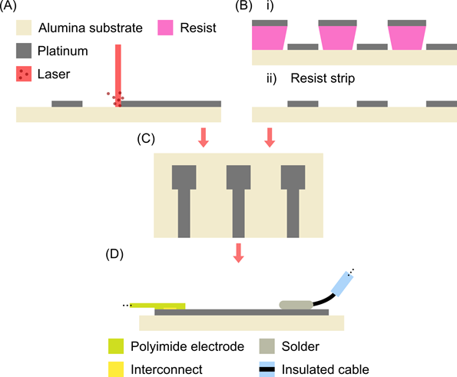

**Figure WP1.1:** Fabrication technologies under investigation for interconnections between a polyimide electrode and a cable. (A) Laser patterning of thin-film platinum on alumina substrate; (B) Via photolithographic means: (i) applying photoresist and sputter deposition of platinum (ii) resist strip resulting in structured thin-film layer; (C) resulting ceramic based interconnects; (D) attached polyimide electrode by microflex bonding and attached insulated cable by soldering.

|  |  |
| --- | --- |
| **Task 1.3 Insulation of high channel count packages** | |
| Lead beneficiary | ALU-FR |
| Start-end month | M6-36 |
| Contributing partners | Chalmers, Unife, UAB |

* **Task summary/description**

This task’s aim is to investigate methods for non-hermetic encapsulation of the implants to establish a stable adhesion of liquid or dry underfill material (such as PDMS) by covalently binding it to substratesfor electrode arrays via tailored adhesion promotion layers. The insulation impedance between adjacent contacts with an integration density of > 100 contacts/cm2 is with defined values of > 250 kOhm at 1 kHz. The investigation of insulation impedance is targeted within this task to examine the ceramic adapter and contact pads insulation using parameters such as time to failure estimation from exposure to physiologic saline solution under accelerated aging conditions. Methods of analysis include imaging (SEM, light microscopy) and material characterization (EDX, ToF-SIMS, FTIR, Raman) methods.

* **Progress of work**

Ongoing -Deliverable No. D1.3

* **Work process in the task** 
  + A project-specific dry underfill process is currently in development. (Figure WP1.2)
  + To investigate the effects of miniaturization i.e. reduction of pitch size on the insulation properties of PI, an experiment using 4-point measurements in collaboration with Chalmers is underway. For that, test sample designs have been planned with an adequate sample size, thicknesses, and relevant pitch increments (1-6 µm, 1 µm increments) to produce results that provide a statistically significant conclusion regarding the feasibility of said miniaturization (Figure WP1.3).
  + The sample size was defined based on a statistical power analysis of the experiment. In order to correctly deduce whether surface modification affects crosstalk, we calculated the minimum number of samples needed not only to detect differences between groups at a p-value of 0.05, but also to determine the magnitude of these differences (which is defined as the effect size). The effect size is classified by J. Cohen into standard deviation units from small (d = 0.2) to very large (d = 1.3) An optimally large effect size (d ≥ 0.8) allows the detection of significant differences with a small sample number, whereas a small effect size requires large sample numbers (Sullivan GM, 2012).

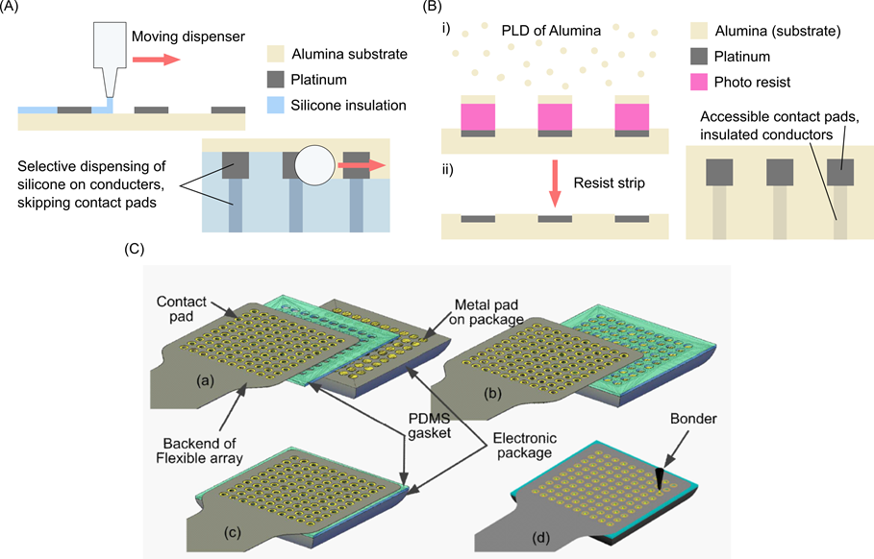

**Figure WP1.2:** Underfill processes under investigation to increase channel insulation. (A) Selective dispensing of silicone on structured interconnect, (B) Pulsed Laser Deposition (PLD) of substrate material (Alumina) with photolithography, (C) Dry underfill with laser patterned PDMS gasket (S. Khan 2018).

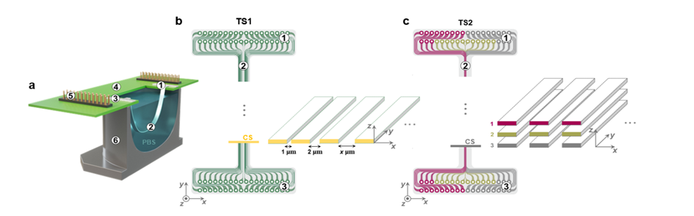

**Figure WP1.3:** Test-structures and setup for measurement of crosstalk between neighbouring conductors in polyimide (PI) (M. Cruz 2021).

* **Summary of results**

Considering a statistical power of 80%, a hypothesized large effect size (d ≥ 0.8), a one-sample one-tail t-test, a minimum of 12 samples per tracks/layers would be required to detect differences between groups at a statistically significant level of p < 0.05.

Different possible insulation/underfill techniques have been identified:

* Selective dispensing of silicone on contact pad area, leaving contact pads free for connection with the electrode contacts via microflex bonding. Parameter investigation is in progress, machine must be properly setup. (Figure WP1.2 (A)).
* Pulsed laser deposition (PLD) allows to deposit stoichiometrically correct alumina (same as base substrate). This can be done in the cleanroom facilities of the IMTEK at UFR, but the machine must be setup first, as processing has not begun yet. In combination with photolithography, we expect stable high-resolution layers insulating individual channels for decreased crosstalk (Figure WP1.2 (B)).
* Dry underfill: in previous work at the UFR dry underfill has been investigated to insulate high channel interconnects. For this, thin layers of PDMS are laser structured to offer vias to allow electrical connection of the contact pads of the interconnection substrate with the contact pads of the electrode by microflex bonding.
* **Adaption from the DoA**
  + A small delay in the establishment of dry underfill process with e.g. PDMS, which is pending due to the maintenance status of the picosecond laser, required for the PDMS patterning.
  + Deviation from the DoA – None thus far
* **Lessons learnt or challenges.**

The challenge presented by the status of the picosecond laser is also connected to the certification status of our laboratory (ISO 13485 certified), that other facilities of the UFR do not offer. We dedicate our work to translational research and try to meet regulatory requirements best possible, e.g. with our commitment to develop devices best possibe in accordance with ISO 10993 and 13485, i.e. using safe materials and a controlled manufacturing environment. In our experience it is good practice to take medical device guidelines and regulations into account as early as possible in the entire development and production of an implant aimed towards human implantation; especially regarding process transfer to different facilities/machines and material compatibility, saving a lot of time and resources in the long term.

#### **1.2.2 Work Package 2- Longevity & Miniaturization**

**Work package overview**

|  |  |  |  |
| --- | --- | --- | --- |
| **Work package number** | WP2 | **Lead beneficiary** | Chalmers |
| **Work package title** | Longevity & Miniaturization | | |
| **Start month** | 1 | **End month** | 36 |
| **Objectives:** | 1) Development of e-beam fabrication method for ultra-flexible PI-based intraneural interfaces with nano-porous electrodes. (2) plasma-based surface modification protocols (3) Validation/verification and stability analysis of  functionalized PI-based implants. | | |

**Summary of progress and work carried out (deliverables and achievements)**

|  |  |  |  |
| --- | --- | --- | --- |
| **Task** | **Progress** | **Partners** | **Summary of Deliverables and Achievements** |
| Task 2.1: Electrode array – design, fabrication and *in vitro* validation | Ongoing (M1-36) | **Chalmers,**  ALU-FR | * All photolithography methods have been fully established. * First steps have been taken towards direct writing of flexible electrode arrays with e-beam and laser. * Most processes are defined and ongoing optimization of resists, exposure levels, etch parameters and hard mask deposition for etching, will allow us to fine tune the pattern transfer and accomplish sub-micron structures with both laser and e-beam lithography. * A battery of test-structures has been outlined, which allow high throughput exploration of process and materials optimization. * Process alternatives together with our design analysis, are summarized in “D2.1 Probe design study”. |
| Task 2.2: Electrode array functionalization using plasma | Ongoing (M6-16) | **Unife,**  Chalmers | * A variety of test substrates have been manufactured and delivered for functionalization tests at Unife. * Protocol where the PI surface is directly activated using the oxygen plasma of the Reactive Ion Etch is under development, in a new collaboration with the surface chemistry group at UFR (Prof. Rühe). A first demonstration is already available showing the process for binding a synthetic hydrogel to PI. |
| Task 2.3: Electrode array stability validation | Ongoing (M6-36) | **Chalmers**,  Unife, ALU-FR, UAB | * *In vitro* validated impedance and stability of sputtered iridium oxide (SIROF) at Chalmers, reproduces the high quality previously established at UFR. Thus, we conclude the chosen material will be stable at least when unmodified. * Test structures dedicated for longevity analysis are under development. |
| Task 2.4: Microsurgical tools & techniques | Ongoing (M6-24) | **Chalmers,**  ALU-FR,UAB | * Chalmers researcher H. Karlsson-Fernberg spent one week at UAB to observe surgeries, as first step towards defining an improved insertion method. * Mechanical pull test has been defined and initial tests on modified PI samples indicates that the functionalization process weakens the material, something that needs to be considered in design of device and insertion methods. Milder functionalization protocols are being explored by WP3. |

**Overview of tasks**

|  |  |
| --- | --- |
| **Task 2.1: Electrode array – design, fabrication and in vitro validation** | |
| Lead beneficiary | Chalmers |
| Start-end month | M1-36 |
| Contributing partners | ALU-FR |

* **Task summary/description**

As outlined in the DoA, flexible BioFINE electrode arrays are to be based on thin-film PI (insulation layers of 2µm), and e-beam lithography will be explored to minimize implant volume. In RP1 we have worked towards direct writing of flexible electrode arrays introducing e-beam but furthermore laser lithography, as a means to create finer patterns of electrodes and connection lines than what is possible with photolithographic methods. In the DoA we stated that we target width/pitch of connection lines to be reduced from 3/6 µm to 0.3 µm spacing/0.6 µm pitch. With laser writing we are currently capable of achieving 1 µm lines and with e-beam lines down to 0.3 µm have been accomplished (Figure 13 in D2.1) bringing us already close to our target. In the next RP we will be able to explore an additional laser system with finer resolution than what is provided by the current laser lithography.

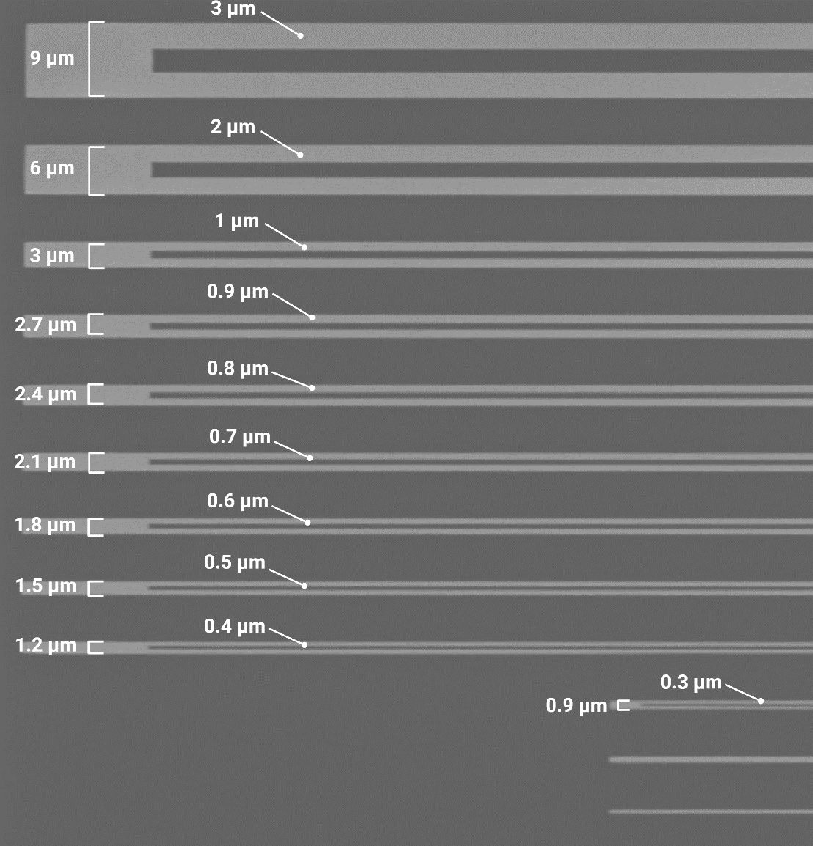

**Figure WP2.1.** SEM micrograph of split bridges of varying linewidths fabricated with e-beam lithography.

**Figure WP2.2.** Process flow description of the developed hard mask etching protocol.

We have next to this established the photolithography methods to enable direct comparison between all techniques. In addition to the various patterning methods, we are optimizing etch parameters and etch masks (transitioning towards hard etch masks) to achieve reliable pattern transfer even when etching thicker layer stacks of PI. To enable single PI layers to be 2 µm, or even go below this number, we are currently exploring dilution of the polymer precursor.

Substantial part of the work in WP2 currently includes analysing design trade-offs, for instance, how thicker metal can be used to increase conductivity of the narrow lines, making it possible to reduce line width. However, this may in turn negatively impact line clearance. We have developed a battery of test structures where we effectively can probe how such fundamental design choices impact performance of pattering process as well as resulting device. From our test structures we have already collected the necessary data on conductivity of platinum vs gold and shown how conductivity of a line scales with layer thickness and line width (Figure 6 in D2.1). In the probe design process, this information will be fed into a COMSOL model supporting the probe layout.

**Figure WP2.3.** Test structures for optimizing metal patterning processes.

In the DoA we defined that we aim for electrodes 10x10 µm2, and initial analysis (Figure 2 in D2.1) has shown that SIROF with or without PEDOT/PSS coating may not be able to reach the necessary charge injection thresholds (20 µA, 300 µs pulse). This is, if we assume that all other aspects (neural excitability, scarring surrounding implant) remain the same. The goal of BioFINE is nevertheless that lower currents can be used once we achieve a reduced scarring process. We have decided that we will use the first generation to explore *in vivo* which size of electrode that is feasible to use for recording vs stimulation. We will include multiple clustered electrodes which can be combined in groups forming a virtually larger electrode or be used individually to explore if effective stimulation is possible from a small area electrode.

* **Progress of work**

Ongoing – and summarized in Deliverable D2.1 Probe Design Study

* **Work process in the task** 
  + Microfabrication processes for all three methods have been established. Photolithography methods are complete, laser lithography methods are established but can be further optimized, e-beam lithography are initially in place, but further optimization remains to reach the target of 300 nm connection lines.
  + Test structure battery is developed, that will serve for evaluation and comparison of all methods above.
  + Conductivity analysis of different metals, as well as thickness has been performed.
* **Summary of results**

We have outlined the necessary methodology to achieve our target specifications of 2 µm thick PI layers, and we are close to our design targets with connection lines as fine as 0,3 µm wide using the e-beam system. We are currently exploring how metallization can be optimised to safe-guard sufficient conductivity in narrow lines.

* **Adaption from the DoA**
  + Establishment of the e-beam process took longer than expected because of limited device access (heavily booked in multiuser facility) but, thanks to the laser writing technique, we were able to substantially advance with this as alternative. This is an addition but not a deviation.
  + Deviation from the DoA - None this far
* **Lessons learnt or challenges**

We foresee it may be difficult to achieve sufficiently potent stimulation from electrodes only 10 x 10 µm2 in size even with the best materials (e.g. PEDOT-coated IrOx) at hand. To be able to use electrodes of Ø < 25 µm we will need the biofunctionalization strategies to improve contact to the tissue so that current can be lowered. The interplay between electrode size, stimulation current and foreign body response will be explored in next RP.

|  |  |
| --- | --- |
| **Task 2.2: Electrode array functionalization using plasma** | |
| Lead beneficiary | Unife |
| Start-end month | M6-16 |
| Contributing partners | Chalmers |

* **Task summary/description**

Chalmers has manufactured and delivered a large number of test structures to the labs at UAB and Unife to support iterations of functionalization processes on their side. As alternative to the pathway defined by Unife, we are also in line with the DoA currently exploring high power plasma generated by the dry etch (Reactive Ion Etch - RIE) used during fabrication as method to insert functional groups on the PI surface. Asplund has initiated this work in a collaboration with Prof. Rühe in Freiburg and have demonstrated that the technique can covalently attach a hydrogel to the PI surface. Together with the Rühe team, we are currently optimizing the process, which then subsequently can be transferred to Chalmers and be made available within the project. In BioFINE this will offer an alternative to activate the surface of PI to generate functional groups (i.e. OH) that will be subsequently used for bio-functionalization as in WP3. This may be useful as a mitigation strategy in case the chemical activation steps are found to penetrate to deeply into the PI material.

* **Progress of work**

Ongoing

* **Work process in the task** 
  + PI devices are delivered to Unife for their exploration.
  + Alternative strategy using dry etch plasma is in progress in a BioFINE external collaboration with Prof. Rühe at UFR. These developments will be further explored to shape an alternative modification process in BioFINE, complementing the Unife protocols.

* **Summary of results**

See report by WP 3

* **Adaption from the DoA** 
  + The possibility to collaborate with Prof Rühe to gain access to specific surface modification protocols, based on RIE plasma modification to immobilize a hydrogel on the PI.
  + Deviation from the DoA - None this far
* **Lessons learnt or challenges.**

Initial mechanical tests (se task 2.4) have indicated a risk that the wet chemistry-based surface modification approach, impacts the bulk of the PI material as well. A new version of the surface modification process at Unife is now being tested (WP3) which we expect will stay confined to modifying the surface only. The alternative plasma etch method mentioned above will here serve as risk mitigation in case it is hard to find a trade-off between retaining integrity of the PI thin-film and achieving effective surface modifications. Surface penetration of plasma is in general easier to control.

|  |  |
| --- | --- |
| **Task 2.3: Electrode array stability validation** | |
| Lead beneficiary | Chalmers |
| Start-end month | M6-36 |
| Contributing partners | Unife, ALU-FR, UAB |

* **Task summary/description**

All electrode arrays will undergo accelerated bench tests to extract the long-term recording and stimulation capability, repeated and compared for conventional PI electrode arrays, e-beam arrays generated within BioFINE, and functionalized PI based arrays. This far we have established the suitable test structures but not yet started longevity testing of finished devices at scale. This will be initiated once the surface modification protocol is at the point where we can exclude any immediate negative effects on the short-term performance of the device.

We have performed longevity tests focussing on the electrode material, showing that the high stability of the SIROF coatings demonstrated previously by us in Freiburg, could be replicated also with materials deposited at Chalmers. In these tests, based on repeated charge injection and voltage cycling of the electrode materials, we could show that impedance, morphology, cyclic voltammogram and overall stability of the material was reproduced at Chalmers.

* **Progress of work**

Ongoing

* **Work process in the task**

We have defined the test structures but not yet proceeded to tests at larger scale.

* **Summary of results**

SIROF as a stable electrode material has been validated and compares well to previous results from Freiburg.

* **Deviation from the DoA**

None this far

* **Lessons learnt or challenges.**

None this far

|  |  |
| --- | --- |
| **Task 2.4: Microsurgical tools & techniques** | |
| Lead beneficiary | Chalmers |
| Start-end month | M6-36 |
| Contributing partners | ALU-FR, UAB |

* **Task summary/description**

In order to safely deliver the ultra-flexible probes in the intraneural vascular space we will need dedicated tools and techniques. As first step in this process Hanna Karlsson-Fernberg, PhD student of the Chalmers BioFINE team, had a shorter research stay with UAB to observe the surgical techniques they currently use on-site. For the first generation it is highly likely that we will be able to use the previously established process for TIME insertions, with a surgical needle pulling the device through the nerve. For the subsequent generations we expect to need a project specific strategy because devices will be much smaller.

An aspect complicating the insertion task is if the mechanical stability of PI is substantially altered by the surface modification protocol. As first step towards exploring how the functionalization protocol impacts device performance, we fabricated mechanical test structures and compared test structures in pull tests with and without surface modification. Surface modification makes the polymer softer, and we expect several process iterations to define the sweet spot where modification is effective without impacting the PI bulk material. We are currently completing the pull tests for the most recent functionalization protocol from WP3 and, will be based on this, decide the final dimensions and the insertion strategy to be used for the first generation of devices. Before tests in animals, we will perform pre-tests to analyse forces when pulled through a nerve model, likely based on tubular agar to mimic the shape and consistency of a nerve.

* **Progress of work**

Ongoing

* **Work process in the task** 
  + Research stay at UAB from H. Karlsson-Fernberg (Chalmers) to observe and understand the surgical boundary conditions.
  + Mechanical pull tests to understand how the functionalization impacts mechanical robustness of the device.
* **Summary of results**

A mechanical pull test was developed allowing to compare mechanical robustness for PI samples treated with different functionalization protocols.

* **Deviation from the DoA**

None this far.

* **Lessons learnt or challenges.**

Initial mechanical tests have indicated a risk that the wet chemistry-based surface modification approach, impacts the bulk of the PI material as well (see Task 2.2), weakening the material. This may call for an adapted insertion process already in generation 1, to ensure that also the surface modified devices are sufficiently stable to the pulled through the nerve. We will consider metallizing the front part of the implant to increase its stability and avoid rupture during the insertion.

#### **1.2.3 Work Package 3 – Surface functionalization**

**Work package overview**

|  |  |  |  |
| --- | --- | --- | --- |
| **Work package number** | WP3 | **Lead beneficiary** | Unife |
| **Work package title** | Surface functionalization | | |
| **Start month** | 1 | **End month** | 36 |
| **Objectives:** | Objectives: 1) to find a general procedure for surface functionalization of PI and PDMS based neural implants; 2) to functionalize PI/PDMS based neural implants with anti-inflammatory drugs; 3) to functionalize PI/PDMS based neural implants with bioactive substrates. | | |

**Summary of progress and work carried out (deliverables and achievements)**

|  |  |  |  |
| --- | --- | --- | --- |
| **Task** | **Progress** | **Partners** | **Summary of Deliverables and Achievements** |
| Task 3.1 General strategy to introduce functional groups on PI | Completed (M1-4) | **Unife,**  Chalmers, ALU-FR | A general procedure to activate PI towards further functionalization has been developed. DEX was successfully incorporated on PI and the amount of released drug was found to be therapeutically relevant, based on literature data. |
| Task 3.2 PI based neural implants as drug delivery systems | Ongoing (M3-24) | **Unife,**  Chalmers, ALU-FR, UAB | The synthetic route outlined in Task 3.1 was translated to the functionalization of PI based neural implant prototypes. *In vivo* studies are currently under investigation to establish the extent of the incorporated DEX anti-inflammatory effect. Deliverable D3.1 has been submitted at the due date (month 10). |
| Task 3.3. Functionalization of PI neural implants with bioactive substrates | Ongoing (M3-24) | **Unife,**  Chalmers, ALU-FR, UAB | The ROS scavenger TEMPO has been covalently incorporated on PI wafers. Its presencewas confirmed by means of ATR-FT-IR, UV analysis and EPR spectroscopy. Further analysis aimed to estimate the ROS scavenging activity is ongoing. |
| Task 3.4 Concept transfer from PI to PDMS based neural implants | Not started (M25-36) | **Unife,**  Chalmers, ALU-FR, UAB |  |

**Overview of tasks**

|  |  |
| --- | --- |
| **Task 3.1 General strategy to introduce functional groups on PI** | |
| Lead beneficiary | Unife |
| Start-end month | M1-4 |
| Contributing partners | Chalmers, ALU-FR |

* **Task summary/description**

General strategy to introduce functional groups on PI (M1-4), Unife, Chalmers, ALU-FR). The synthetic route was optimized following the initial plan as reported in the DoA. In particular, the proposed hydrolysis of the imide ring in alkali solution was adopted to generate surface carboxylic functions on PI, to give the activated PI-CO2H that bears surface carboxylic acid groups. Hydroxyl moieties have been introduced through Steglich’s protocol using various amino alcohols. The best candidate was found to be tris(hydroxymethyl)aminomethane, which is commercially known also as Trizma base, owing to the fact that it exhibits three OH groups every amine site. This enabled the construction of a very dense monolayer of surface OH sites that can be subsequently functionalized by alkoxy-silane derivatives. In particular, the commercially available (3-triethoxysylil) propylsuccinic anhydride (SAPTES) resulted the optimal choice, since produced a 3D scaffold to insert the drug (DEX). Nevertheless, silanization of activated PI was also obtained with 3-Aminopropyl)triethoxysilane (APTES), according to the DoW, to give pendant NH2 linkers anchored to PI by siloxane bonds. The optimization of the process was performed on large scale PI samples that were coated on Si wafer by Chalmers unit. The optimal conditions were then transferred to the functionalization of neural implant prototypes.

* **Progress of work**

“Completed” as far as the activation protocol is concerned. Nevertheless, based on result that are constantly achieved for Task 3.2, task 3.1 is expected to be kept constantly updated, thereby resulting Ongoing, from this perspective -Deliverable No.3.1 was sent on the due date.

* **Work process in the task**
* alkali hydrolysis of PI to give the activated PI-CO2H that bears surface carboxylic acid groups.
* hydroxyl moieties have been introduced through Steglich’s protocol using Trizma base.
* construction of a porous 3D scaffold composed by SAPTES or APTES
* **Summary of results**

A general and reproducible synthetic procedure to chemically activate the surface of PI was found. This enables the construction of 3D polysiloxanes based scaffold onto which drugs and/or biomolecules will be covalently grafted.

* **Adaption from the DoA**
  + Currently the only adaption needed from the DoA can be represented by the use of a different silane. In the DoA the silane (3-Aminopropyl)triethoxysilane (APTES) was mentioned, in order to insert pendant amino groups within a 3D architecture. Albeit the functionalization of PI with APTES was achieved, this route did not enable the incorporation of DEX. Nevertheless, APTES functionalized PI will be explored during the next phase of BioFINE to explore the incorporation of new molecular systems, apart from DEX.
  + Deviation from the DoA – None this far
* **Lessons learnt or challenges**

The alkali treatment which is used to activate the surface of PI produces a slight degradation of the uppermost surface, as expected. This yield the release of polyamic acid fragments when the activated PI is put into water, as outlined by UV-Vis spectroscopy. Thus, to remove all poorly adhered fragments, the activated PI was further treated at room temperature in water and the release was monitored over time in order to establish the formation of a stationary phase. After 24 hours, the fragments can be removed, and the activated PI can be further functionalized according to BioFINE’s goals. In the future, other activation protocols will be explored, in particular those based on plasma irradiation (in conjunction with the unit of Chalmers) to compare the “dry route” with the “wet synthetic strategy” currently adopted.

|  |  |
| --- | --- |
| **Task 3.2 PI based neural implants as drug delivery systems** | |
| Lead beneficiary | Unife |
| Start-end month | M3-24 |
| Contributing partners | Chalmers, ALU-FR, UAB |

* **Task summary/description**

Following the activation protocol and the subsequent insertion of Trizma, the silane SAPTES was used to construct a 3D porous structure on the top of PI. This platform was used to covalently insert the first candidate DEX, as summerized in Figure WP3.1. In particular, owing to the presence of succinic anhydride groups on the SAPTES film, DEX was incorporated through the formation of ester linkages at the alcohol site of the drug. This protocol was expected to give a drug delivery system based on the hydrolysis of the ester bond between DEX and SAPTES.

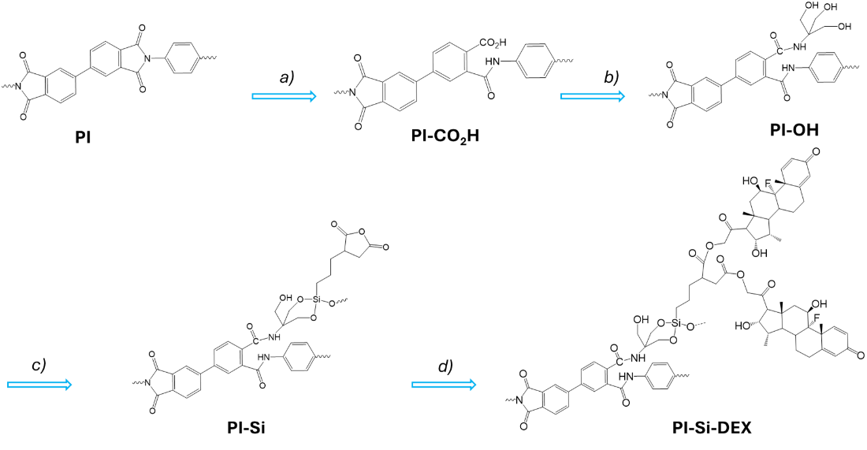

**Figure WP3.1.** Synthetic route to the DEX incorporated PI (PI-Si-DEX).

Direct incorporation of DEX on the activated PI-CO2H through the formation of an ester bond with the OH group of DEX, as confirmed by ATR-FTIR analysis. Nevertheless, the quantification of DEX from the release media was not possible likely due to the fact that the amount of released drug was below the LOD/LOQ of the analytic protocol (HPLC-UV), which were estimated on the order of 0.25/0.13 mM, respectively. In addition to DEX, another family of drugs has been taken into account to reduce the inflammatory response, in accordance with BiOFINE aims. In particular, it was reported that local delivery of the nucleotide-binding oligomerization domain-like receptor family pyrin domain containing 3 (NLRP3) inflammasome inhibitor MCC950, through its incorporation into the silicone coating of implants, reduced the inflammation and fibrosis associated with peripheral nerve injury implant model (DOI: 10.1073/pnas.2115857119). From a chemical point of view the molecular system MCC950 is a secondary alcohol, and its reactivity is thus similar to DEX. Nevertheless, we believe that the use of a primary alcohol, instead, may turn out to be more appropriate in terms of reaction rate towards the formation of ester bonds with SAPTES functionalized PI. Thus, the idea was to find an inflammasome inhibitor that preserve both the therapeutic effect of the model MCC950 and the reactivity exhibited by DEX. Fortunately, the Unife team member Prof. Trapella has recently published a study that reports a new NLRP3 inflammasome inhibitor, named TDV-19, which exhibit comparable activity to MCC950, but is a primary alcohol. Thus, TDV-19 was selected for BioFINE as an ideal alternative to MCC950 thanks to its higher reactivity. The synthesis of TDV-19 was therefore achieved as well as its incorporation on PI-SAPTES, following the synthetic route outline for the incorporation of DEX. *In vitro*/vivo studies are undergoing together with the unit of Barcellona to assess the therapeutic activity of TDV-19.

* **Progress of work**

*Ongoing* – Deliverable No.3.1- submitted

* **Work process in the task**
* Direct incorporation of DEX on activated PI-CO2H
* Incorporation of DEX on SAPTES functionalized PI
* Synthesis of the new inflammasome inhibitor TDV-19
* Incorporation of TDV-19 on SAPTES functionalized PI
* **Summary of results**

DEX was incorporated on SAPTES functionalized PI samples, and the kinetic of release was evaluated *in vitro,* as reported in Figure WP3.2*.* Analysis of *in vitro* release confirmed an overall incorporated drug that ranges between 60 and 25 nmol cm-2. Experimental outcomes yielded a daily dosage of DEX significantly larger than 0.25 nmol cm-2, which represent the dosage of drug that should be released to exert a therapeutic effect, according to the literature (Y. Zhong, R. V. Bellamkonda, Brain Res. 2007, 1148, 15–27). This optimal situation was confirmed for more than six weeks, but in some cases even for more than 8-9 weeks. This means that the developed drug delivery system based on the incorporation of DEX on SAPTES functionalized PI samples, is likely to reduce the inflammation which is typically observed during the acute phase post implantation in general lasting for about 3-4 weeks.

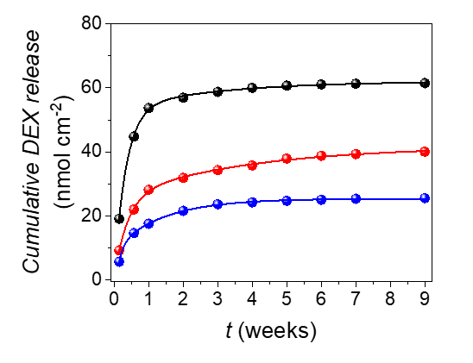

**Figure WP3.2:** Experimental (dots) and theoretical (lines) release data obtained for 3 different PI substrates in PBS pH 7 at 37°C.

In addition, the direct incorporation of DEX has also been achieved. Nevertheless, the impossibility of estimating the amount of release DEX means that its dosage is lower than the LOD of 0.13 mM the analytical technique, corresponding to a released amount of DEX of » 0.04 nmol cm-2, which is far below the therapeutically relevant dosage proposed in the literature. *In vitro* and *in vivo* experiments are ongoing in order to monitor the inflammatory inhibitor capability of the new TDV-19 system.

* **Deviation from the DoA**

None this far

* **Lessons learnt or challenges**

The direct incorporation of DEX on the activated PI-CO2H yielded a too low dosage of drug release. Thus, the construction of the proposed 3D silane-based scaffold is mandatory to prepare an optimal drug delivery platform for fulfilling the BioFINE goals.

Based on the synthetic approach that has been optimized, it could be possible, theoretically, to incorporate on PI implant both DEX and a different drug, like for instance TDV-19. This is very challenging and interesting at the same time, because it would give us a dual drug delivery system that can deliver two highly efficient drugs at the same time.

|  |  |
| --- | --- |
| **Task 3.3. Functionalization of PI neural implants with bioactive substrates** | |
| Lead beneficiary | Unife |
| Start-end month | M3-24 |
| Contributing partners | Chalmers, ALU-FR, UAB |

* **Task summary/description**

Following a similar procedure the ROS scavenging amino-TEMPO was incorporated on PI-SAPTES through the formation of the highly stable amide bonds. In this way, TEMPO can exert its ROS scavenging capability at the interface between PI and the environment.

* **Progress of work**

Ongoing

* **Work process in the task**
* Incorporation of amino-TEMPO on SAPTES functionalized PI
* Two peptide sequences were synthesized and are ready to be used for PI functionalization
* **Summary of results**

The ROS scavenging substrate amino-TEMPO was successfully incorporated on SAPTES functionalized PI, according to a re-adapted protocol as reported in Figure WP3.1, and the evaluation of the ROS scavenging activity is ongoing. Among other bioactive substrates, two recognized peptides i.e. a laminin-derivative (Ac-CGGASIKVAVSOH) and a bioactive sequence (KHIFSDDSSE) involved in the scarring process were synthesized. Their incorporation on PI is ongoing but it is expected to occur through the formation of ad hoc silane-based scaffolds.

* **Adaption from the DoA**
  + With respect to the original DoA, the incorporation of biomolecules on PI will be achieved through the construction of a 3D scaffold based on the silane chemistry. This modification of the original plan is motivated by the results obtained in Task 3.2, in order to increase the amount of incorporated substrate to achieve an efficient therapeutic effect.
  + Deviation from the DoA – None this far
* **Lessons learnt or challenges**

Based on the synthetic approach that has been optimized, it could be possible, theoretically, to incorporate on the PI implant both a drug that can be delivered and a molecule that is thought to remain attached to the surface, like for instance TEMPO. This is very challenging but future studies will be oriented also towards this kind of approach.

#### **1.2.2 Work Package 4 – In-vivo modulation of the FBR**

**Work package overview**

|  |  |  |  |
| --- | --- | --- | --- |
| **Work package number** | WP4 | **Lead beneficiary** | UAB |
| **Work package title** | In-vivo modulation of the FBR | | |
| **Start month** | 1 | **End month** | 36 |
| **Objectives:** | (1)To perform the needed investigations in experimental animals in order to test biocompatibility and safety, optimize the design and assess functionality of newly developed nerve electrodes, (2) To investigate the cellular and molecular mechanisms involved in the FBR to neural Implanted electrodes, (3) To define new targets for selecting compounds and factors to be attached to the neural electrodes, (4) To assess *in vivo* the different biomimetic strategies to improve electrode-nerve integration and reduce scar tissue formation. | | |

**Summary of progress and work carried out (deliverables and achievements)**

|  |  |  |  |
| --- | --- | --- | --- |
| **Task** | **Progress (completed, ongoing or not started)** | **Partners** | **Summary of Deliverables and Achievements** |
| Task 4.1: Biocompatibility and safety evaluation of electrodes chronically implanted in peripheral nerve | Ongoing (M4-32) | **UAB,**  ALU-FR, Chalmers | New design of intraneural electrodes defined with Chalmers |
| Task 4.2: *In vivo* testing of strategies to reduce fibrotic reaction to the implanted intraneural electrodes | Ongoing (M13-36) | **UAB,**  Unife, ALU-FR, Chalmers | First intraneural implants realized with PI devices that have DEX bound |
| Task 4.3: Investigation of the inflammatory profile induced by neural implants and modifications with treatments | Ongoing (M1-12)  Not started (M24-36) | **UAB,**  Unife | *In vitro* model established. The first selected compounds are tested. |

**Overview of task**

|  |  |
| --- | --- |
| **Task 4.1: Biocompatibility and safety evaluation of electrodes chronically implanted in peripheral nerve** | |
| Lead beneficiary | UAB |
| Start-end month | M4-32 |
| Contributing partners | ALU-FR, Chalmers |

* **Task summary/description**

Once the newly developed electrode designs will be produced in WP1 and WP2, tthe UAB team will test them by chronically implanting in the rat sciatic nerve and quantifying the functional and histological effects on the nerve. Electrophysiological, morphological and immunohistochemical techniques will be used to determine whether axonal injury and functional deficit are produced and the time evolution. Along the follow-up, the animals will be assessed by motor and sensory nerve conduction tests, pain sensibility testing, and walking analysis to determine any possible functional deficit. Immunohistochemical analyses will be performed to assess chronic FBR.

This task will be repeated in any new design of intraneural electrode that will be produced in WP1-2.

* **Progress of work**

Ongoing

* **Work process in the task**
* During the first part of Task 4.1 the UAB team has defined the design and dimensions most adequate for the new intraneural electrodes to be manufactured in WP2. This information was refined and delivered in October 2023, after a visit to the UAB lab of a researcher from CUT (Hanna Karlsson-Fernberg). The refined design is based on the TIME electrode design, but refined with some modifications to increase the stability once inserted in the nerve, and the adequate dimensions for implantation in the rat sciatic nerve, the initial model of this project.The electrophysiological settings for evaluating the capabilities for stimulating and recording from the nerve of intraneural and extraneural electrodes have been optimized, using electrodes from previous projects. The analysis of the responses has been also automatized using MatLab scripts.
* **Summary of results**

The proposed design for the BioFINE intraneural electrodes is shown in Figure WP4.1.

**Figure WP4.1:** Initial layout for the 1st generation of BioFINE implants for studies of biocompatibility and functionality of the novel electrodes.

* **Adaption from the DoA**
  + Deviation from the DoA - None this far

|  |  |
| --- | --- |
| **Task 4.2: In vivo testing of strategies to reduce fibrotic reaction to the implanted intraneural electrodes** | |
| Lead beneficiary | UAB |
| Start-end month | M13-36 |
| Contributing partners | Unife, ALU-FR, Chalmers |

* **Task summary/description**

To evaluate the FBR to intraneural electrodes, we have used a well standardized animal model (De la Oliva et al 2018). A PI device is inserted longitudinally in the rat sciatic nerve, and maintained for 2 and 8 weeks, to assess the presence of macrophages and the area of fibrotic capsule around the electrode device. The advantages of using longitudinal implants are that it creates a stable implant of 10-15 mm inside the nerve with high reproducibility to study the FBR. In our model, the FBR stems from the interaction between the nerve tissue and the device itself, without confounding contribution of other external factors, such as variability of implantation or tethering forces of the wires. Passive devices of PI provided by Chalmers team have been inserted longitudinally in the tibial branch of the sciatic nerve of rats. Functional tests as in Task 4.1 are performed to evaluate possible nerve damage. After 2 and 8 weeks post-implant, the sciatic nerve including the implanted device is harvested for histological and immunohistochemical analyses. Analysis of infiltrating macrophages, fibroblasts and foreign body giant cells in the implanted nerves is performed using immunohistochemical labelling. . For each treatment or condition, one group of rats is used and compared with control intact nerves and control devices-implanted nerves.

* **Progress of work**

Ongoing

* **Work process in the task**

Longitudinal intrafascicular devices of PI as control or PI with DEX attached, provided by UNIFE (Task 3.2), have been implanted in the sciatic nerve of Sprague–Dawley (SD) rats. Each device has two arms that are bent to face each other. The devices are inserted longitudinally in the tibial fascicle of the sciatic nerve. Functional and histological analyses are performed at 2 weeks after the implantation concurrent with the peak of the inflammatory foreign body reaction, following a defined procedure (De la Oliva et al 2018).

To evaluate the functional properties of the nerves implanted with longitudinal devices, walking track test to assesses locomotion, algesimetry test to evaluate hyperalgesia, and electromyography tests to assess neuromuscular function are conducted. To study the FBR associated with the implant, the nerves are collected and fixed. Transversal sections are labeled for ionized calcium–binding adapter molecule 1 (Iba1) to quantify the number of infiltrating macrophages. The capsule thickness around the implant is measured from the implant to the closest axons labeled for neurofilament 200 kDa.



**Figure WP4.2:** Motor nerve conduction results of animals implanted with PI or PI with bound DEX in comparison with the contralateral intact side during 2 weeks. n=5 animals per condition. Two-way ANOVA followed by post-hoc Bonferroni test for multiple comparisons.

* **Summary of results**

The devices implanted correspond to the first batch of samples released by UNIFE.

The functional tests performed (walking track, algesimetry, and electromyography) did not show any significant difference compared to the contralateral paw, indicating that the implant did not affect the neuromuscular function nor generate hyperalgesia (Figure WP4.2). Animals with implants containing DEX had similar results to animals with the plane PI implant in the functional tests.

The histological analysis (Figure WP4.3 and Figure WP4.4) showed that in the PI devices pre-treated with DEX, macrophage recruitment to the implant site was significantly lower compared to the untreated PI devices. However, at 2 weeks post-implantation, no significant changes in capsule size were observed with respect to untreated samples.

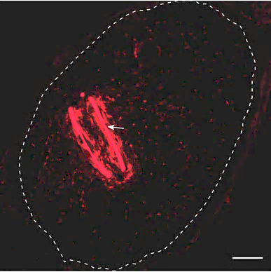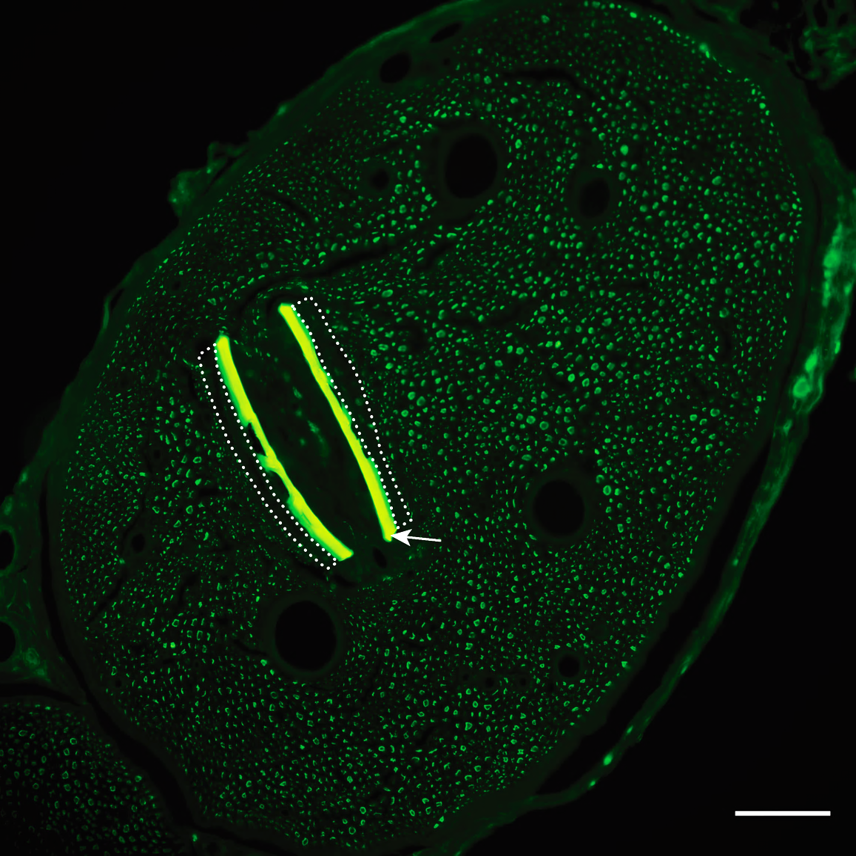

**Figure WP4.3:** Micro-graphs of transverse sections of the tibial nerve with a PI longitudinal implant. ***Left:*** immunolabeling for macrophages. ***Right:*** labelling for axons. Note the autofluorescence of the PI material (arrow).



**Figure WP4.4: Effect of DEX bound to PI devices on the FBR to intraneural implants.** A: Number of inflammatory Iba1+ cells in the tibial nerve of animals implanted with PI devices pre-treated with DEX and controls. B: Tissue capsule thickness around the PI devices in the tibial nerve. n=5 animals per condition. t-test *p<0.05.

* **Deviation from the DoA**
  + Task 4.2 has been advanced in WP4, in relation with the production of functionalized devices in WP3, and being performed in correspondence with Task 4.3. We propose Task 4.2 to encompass months 10-36.
* **Lessons learnt or challenges**

Not applicable

|  |  |
| --- | --- |
| **Task 4.3: Investigation of the inflammatory profile induced by neural implants and modifications with treatments** | |
| Lead beneficiary | UAB |
| Start-end month | M1-12, M24-36 |
| Contributing partners | Unife |

* **Task summary/description**

The sets of PI devices from T3.2 are first tested in culture of macrophages on top of pieces of PI with the different compounds selected. Macrophages are activated with LPS and the cell reactivity and the release of cytokines assessed. We have demonstrated that the *in vitro* tests help to define the most effective conditions for further testing *in vivo*. To further characterize the triggering and contributing factors to the inflammatory response to devices implanted in the peripheral nerve, a set of cytokines and chemokines are quantified using PCR and Luminex methods. This analysis was previously made for PI and parylene control devices, providing comparative information to detect the effects of the different treatments, as well as to shed light on novel targets for continuing studies.

* **Progress of work**

Ongoing

* **Work process in the task**

As macrophages play a leading role in the foreign body reaction, a bone marrow derived macrophage culture was chosen to study the inflammatory profile induced by neural implants. Briefly, monocytes are obtained from the bone marrow of SD rats. The cells are allowed to mature by adding macrophage colony-stimulating factor (M-CSF) to the culture medium. Once macrophages are fully mature, LPS is added to the medium to induce macrophages activation, mimicking the reactive state produced after the implantation of a PI device in the nerve. Different wells have been treated by adding to the medium DEX (anti-inflammatory drug), MCC950 and TDV19 (inflammasome inhibitors), compared with untreated wells. More drugs will be investigated in future experiments.

The production of NO in the culture medium, which is indicative of inflammatory processes, is analyzed using the Griess method. The gene expression of different proinflammatory (IL-6, TNF-a, IL-1ß) and anti-inflammatory (IL-10, IL-13) cytokines is also analyzed by qPCR from the cells pellet.

* **Summary of results**

The *in vitro* model proposed for this WP has been developed in the UAB laboratory, and the most adequate conditions, in terms of concentration of LPS added to the medium and the time schedule of exposure and treatment defined. This initial work has allowed to establish a useful *in vitro* model for assessing compounds that may have an effect in modulating the FBR.

In the first sets, we compared untreated PI samples with samples in which DEX was surface bound (Task 3.2) and with devices to which DEX was added to the culture medium, all exposed to LPS (Figure WP4.5). The presence of DEX tended to reduce NO production, and also reduced IL-6 expression significantly, and showed a tendency, although not significant, to reduce IL-1ß expression. However, TNF-α expression was significantly increased in samples releasing DEX. On the other hand, of the anti-inflammatory cytokines, IL-10, but not IL-13, increased its expression significantly in devices with DEX.



**Figure WP4.5: Effects of DEX treatment on cytokine production from macrophages exposed to LPS**.Sist.Dexa:DEXadded to the medium; Dexa: DEX bound to the PI device. By using RT-qPCR, expression of different genes was analyzed. **A-C:** pro-inflammatory cytokines IL-6, TNFa and IL1b. **C-D**: anti-inflammatory cytokines IL-10 and IL-13. n=3 experiments per condition. One-way ANOVA followed by post-hoc Bonferroni test for multiple comparison. *p< 0.05, ***p<0.001. **E:** Production of Nitric Oxide in different conditions (n=4 experiments).

We have also assessed the inflammasome inhibitory compounds MCC950 and TDV19, added to the macrophage culture medium. Both compounds produced a similar response, reducing the production of NO, and decreasing the expression of IL-6, in response to LPS compared to untreated cells. However, TNF-a expression was increased, suggesting that it is expressed very rapidly, and the compounds are not able to reduce it. The expression of anti-inflammatory cytokines IL-10 and IL-13 was decreased after the treatment with MCC950 and TDV19, suggesting that the inhibition of the inflammasome suppresses the expression of all cytokines.



**Figure WP4.6: Effects of MCC950 and TDV19 on cytokines production in macrophages exposed to LPS.** MCC950 or TDV19 were added to the culture medium at concentrations of 5 or 10 µM. By using RT-qPCR, the expression of different genes was analyzed. A-B: pro-inflammatory cytokines. C-D: anti-inflammatory cytokines. E: Production of Nitric Oxide in different conditions. n=4 experiments per condition. One-way ANOVA followed by post-hoc Bonferroni test for multiple comparison. **p<0.05, ***p<0.001.

* **Adaption from the DoA**
  + We plan to expand Task 4.3 during months 13-23, i.e. along the full duration of the project, in order to increase the compounds screened before *in vivo* implants in Task 4.2, and corresponding to new advances developed in WP3.
  + Deviation from the DoA - None this far
* **Lessons learnt or challenges**

The *in vitro* model to assess macrophages reactivity has been set up, and it represents a valuable method for screening inflammatory modulators.

#### **1.2.2 Work Package 5 – Coordination**

**Work package overview**

|  |  |  |  |
| --- | --- | --- | --- |
| **Work package number** | WP5 | **Lead beneficiary** | Chalmers |
| **Work package title** | Coordination | | |
| **Start month** | 1 | **End month** | 36 |
| **Objectives:** | (1) Framework for the overall financial, scientific and technological management as well as internal evaluation with regards to the planned objectives. (2) Coordination of dissemination and exploitation activities of project results. (3)  Development of Data Management Plan and IPR strategy. (4) Coordination of reporting procedures and communication with EC | | |

**Summary of progress and work carried out (deliverables and achievements)**

|  |  |  |  |
| --- | --- | --- | --- |
| **Task** | **Progress (completed, ongoing or not started)** | **Partners** | **Summary of Deliverables and Achievements** |
| Task 5.1: Coordination and project management | Ongoing (M1-36) | **Chalmers,**  ALU-FR, UAB, Unife | * Pre-financing distributed * Consortium agreement signed * All meetings in accordance with the plan |
| Task 5.2: Progress monitoring | Ongoing (M1-36) | **Chalmers,**  ALU-FR, UAB, Unife | * 6 deliverables submitted on time * 3 Milestones reached on time * Consortium informed about the Reporting period requirements * Coordination of reporting procedures and communication with EC |
| Task 5.3: Dissemination of results | Ongoing (M1-36) | **Chalmers,**  ALU-FR, UAB, Unife | * D5.1: Website and project logo (M2) * D5.2: Plan for Dissemination and Exploitation Including communication Activities (M6) * D5.3: Data Management Plan (M6) |
| Task 5.4: Exploitation of results for bionic limbs | Not started (M24-36) | **ALU-FR**,  UAB, Unife, Chalmers | N/A |
| Task 5.5: Exploitation of results for preclinical market | Not started (M24-36) | **ALU-FR**,  UAB, Unife, Chalmers | N/A |

**Overview of tasks**

|  |  |
| --- | --- |
| **Task 5.1: Coordination and project management** | |
| Lead beneficiary | Chalmers |
| Start-end month | M1-36 |
| Contributing partners | ALU-FR, UAB, Unife |

* **Task summary/description**

This task is dedicated to the overall coordination and project management aspects as well as the organisation of the project meetings.

* **Progress of work**

The task will be ongoing for the duration of the project.

* **Work process in the task**

The task is led by Maria Asplund (Chalmers) in her capacity as the project Coordinator for BioFine project, with support from Terpsi Ketegeni (Chalmers), project manager, and the participation of all partners.

During the 1st Reporting period, the team worked on the following tasks:

* Consortium Agreement. The Consortium agreement was agreed and signed by all partners.
* Pre-financing. Chalmers distributed the pre-financing of 1,5 mil € to partners in a timely manner.
* Documents’ repository. The team identified Sharepoint, as the best cloud option for sharing documents in a safe way among partners. The structure of the folders is intuitive, and efforts are made to upload the latest documents so all partners can easily access them at any point.
* Project E-mail lists were created for the project, allowing timely sharing of information with the consortium or specific groups within the consortium. The lists are a) Principal Investigator list, b) Researcher list, c) Legal and finances list and d) Management list.
* **Templates** for thedeliverables, presentations and agendas were prepared.
* **Kick-off meeting.** The kick-off meeting was organised digitally on 16th of May 2023, with the participation of thewhole team and with the aim of kickstarting the project and to discuss the work plan, project organization, information flows and to allow for team building.
* **Project meetings.** Project meetings or consortium meetings are taking place on a yearly basis, with the location rotating among the partners. The 1st project meeting, hosted by Unife partner, took place in Ferrara, Italy, on 06th and 07th of September 2023 (Figure WP5.1). The agenda included presentations of the technical and financial situation of the project, the technical progress of all work packages, achievements, problems and solutions, management, dissemination, and exploitation aspects.

Figure WP5.1: Consortium meeting in Ferrara held on 06-07/09/2023.

* **Work Package meetings.** Monthly work package meetings are organised on the first Monday of each month with the participation of the entire consortium. The aim of these meetings is for each WP to update on the status of their work, results, potential deviations, problems, and solutions. During the 1st Reporting period, a total of 10 meetings has been organised (digitally) as follows, and in addition the kick off and consortium meeting,

|  |
| --- |
| * **2023 –** 27th of June,27th of July, 28th of August, 09th of October, 06th of November, 04th of December |
| * **2024 –** 8th of January, 5th of February, 4th of March, 25th of March |

* **Technical meetings** to tackle specific issues are being organized by the members of the interested WPs, as needed.
* **Scientific Advisory Board.** The external scientific advisory board was established early in the project, and it consists of three members - one representative from an SME (Martin Schüttler, CTO at CorTec), one scientific (Stanisa Raspopovic, ETH, Zürich) and one scientific/clinical advisor (Jennifer Ernst, Medizinische Hochschule Hannover) with the aim to give direct feedback on developments and plans of the project. Non-disclosure agreements were signed for the three members. The 1st meeting was held digitally on 22nd of January 2024 with the participation of the three external advisors and the entire consortium team.
* **Summary of result(s)**

The project is running smoothly, with the entire team well-informed about the overall project progress. The project management structure is in place, the pre-financial payment was executed, and the meetings are being organized in accordance with the project time-plan.

* **Deviation from the DoA**

Not applicable

* **Lessons learnt or challenges**

Not applicable

|  |  |
| --- | --- |
| **Task 5.2: Progress monitoring** | |
| Lead beneficiary | Chalmers |
| Start-end month | M1-36 |
| Contributing partners | ALU-FR, UAB, Unife |

* **Task summary/description**

Progress of project based on milestones and progress reports (M12, M36) and review meetings. Intermediate reports and final report.

* **Progress of work**

The task will be ongoing for the duration of the project.

* **Work process in the task**

The overall progress of the project is being monitored during the monthly working meetings where the work package leaders present the status of their respective work packages. In addition, the progress of the deliverables are being discussed as well as milestones and risks.

During the 1st reporting period, a total of 6 deliverables were submitted (all according to the timeplan):

|  |  |  |  |  |  |  |  |
| --- | --- | --- | --- | --- | --- | --- | --- |
| **Work Package No** | **Deliverable Name** | **Lead Beneficiary** | **Type** | **Dissem. Level** | **Due Date** | **Delivery Date** | **Status** |
| WP1 | D1.1. - Implant target specifications | ALU-FR | R | SEN | 31 Mar 2024 | 31 Mar 2024 | Submitted |
| WP2 | D2.1 - Probe design study | CHALMERS | R | SEN | 31 Mar 2024 | 31 Mar 2024 | Submitted |
| WP3 | D3.1 - Biofunctionalization of PI | Unife | R | SEN | 31 Jan 2024 | 29 Jan 2024 | Submitted |
| WP5 | D5.1 - Website and project logo | CHALMERS | R | PU | 31 May 2023 | 31 May 2023 | Submitted |
| WP5 | D5.2 - Plan for Dissemination and Exploitation Including Communication Activities | CHALMERS | R | PU | 30 Sep 2023 | 29 Sep 2023 | Submitted |
| WP5 | D5.3 - Data Management Plan | CHALMERS | DMP | PU | 30 Sep 2023 | 30 Sep 2023 | Submitted |

The preparations for the 1st reporting period included:

* Informing the consortium about the EC review requirements;
* Preparing a time-plan with actions for the project team;
* Preparing different templates for collecting info – technical report, financial reports, etc.
* Preparing a draft agenda for the EC review meeting;
* Extensive communication with the EC Project officer regarding the EC review meeting – draft agenda, external experts, date for the meeting, etc;
* Setting up extra meetings dedicated to the EC review meeting;
* Communication with the financial officers at the partner’s institutions for clarifying financial issues;
* Preparing scientific presentations for the EC Review meeting;
* Compile a list of experts to be used as external evaluators;
* Preparing the deliverable D5.4 - RP1 Technical/scientific review meeting documents.
* **Summary of results**

Overall, the team submitted 6 deliverables and reached 3 milestones on time, as per the project’s time-plan. In addition, the consortium is informed about the reporting period requirements and worked on the technical and financial aspects of the project in view of the 1st EC review meeting.

* **Deviation from the DoA**

Not applicable

* **Lessons learnt or challenges**

Not applicable

|  |  |
| --- | --- |
| **Task 5.3: Dissemination of results** | |
| Lead beneficiary | Chalmers |
| Start-end month | M1-36 |
| Contributing partners | ALU-FR, UAB, Unife |

* **Task summary/description**

This task has made progress in RP1 as follows: We have created a project website and installed additional media channels such as a project dedicated LinkedIn group account. We have furthermore defined of the Data Management Plan (DMP) for storage, curation and sharing of experimental data. Most measures in the DMP are activated upon publication of scientific results. In the following RPs we expect to generate a variety of publication outputs and at the moment the project is still early stage research. The project has been represented at key conferences

[HERE WE SHOULD LIST SOME SPECIFICS]

Planned workshops for clinicians and neuroscientists as mentioned in the DoA is part of future work in the project.

* **Progress of work**

The task will be ongoing for the duration of the project.

* **Work process in the task**

a. Project website & Logo

The team created the project logo and the website by month 2, in accordance with the project timeplan. The website, is accessible at the link [www.biofine.eu](http://www.biofine.eu) and consists of the following 5 categories that are being updated whenever necessary:

1. About us
2. Partners
3. Contact
4. Publications
5. Outreach

To support project outreach, the team has also established the LinkedIn group “BioFINE‐project”

<https://www.linkedin.com/groups/12848129/>

A more detailed account of this activity can be found at the deliverable D5.1 – Website and project logo.

b. Data Management Plan

The team created the first version of data management Plan in accordance with the FAIR principles. More info can be found at the deliverable D5.3 – Data Management Plan.

**c. Communication activities**

* **Summary of results**
  + Deliverable D5.1 – Website and project logo.
  + Deliverables D5.2 - Plan for Dissemination and Exploitation Including Communication Activities
  + Deliverables D5.3 – Data Management Plan
* **Deviation from the DoA**

Not applicable

* **Lessons learnt or challenges**

Not applicable

### 1.3 Impact

**Impact on citizens:** An amputee loses capabilities of performing hand movements and grasping, but also to sense and explore the surrounding world, as well as the ability to use gestures to support communication. Bionics is about restoring such functionality by providing artificial prosthetic limbs with direct control and feedback, using the remaining nerves in the stump as recording and stimulation targets. The ideal is to achieve intuitive motor control and natural-like sensory feedback, and there intraneural body-machine interfaces have emerged as one of the most promising opportunities. Current implants are however limited in their ability to permanently integrate with surrounding tissue. It is only by improving their biocompatibility, biointegration and performance longevity that they will reach their full potential to improve lives of patients suffering from limb amputation. In the bionics domain, which is our pilot case, we expect the technology developed to in the longer perspective, improve individuals’ quality of life enhancing working capacity, and to have a positive impact on the socio-economic burden: people will be able to improve performance in activities of daily life, and return to work after receiving a prosthetic limb device. If successful, this is the most important societal impact, that more patients will be able to benefit from such implants as a life-long treatment. The societal impact is nevertheless only possible with technology that can be successfully clinically translated, which for medical devices is uniquely coupled to the potential economic impact of the technology. This is because of regulatory requirements necessitating a legal person, a company, to accept the long term legal and financial responsibility for putting a new medical device on the market, which includes post market surveillance of the therapeutic device.

**Impact on economy:**

Importantly, since BioFINE chooses to focus on two materials that currently dominate in translational neurotechnology and bionics, namely PI and later in the project poly-di-methyl-siloxane (PDMS), the functionalization protocols and findings will be transferrable to a much broader neurotechnological innovations beyond bionic limbs. Neuroelectronic medicine is currently in an expansive phase with a broad spectrum of companies involved, from major established players (e.g. Medtronic, DIXI medical), to SMEs (e.g. Europe: CorTec Neuro, INBRAIN Neuroelectronics; Panaxium, X-trodes, NanoRetina, WISE, NeuroLoop and ALEVA, US: Blackrock Neuro, NeuroOne, PrecisionNeuro, NeuraLink) and start-ups (e.g. ATLASNeuro, Phosphoenix). In particular, substantial investments are made to introduce polyimide as an approved medical material, which means the timing is perfect for developing new processing methodology to improve implants based on this particular material. This relates both to new methodology for further miniaturization (WP1 and WP2) and to functionalization of implant surfaces (WP3).

The project has been able to advance with results in both these domains, although further improvements will be needed over the next RP2, to increase impact. Specifically, this far, the project has achieved possible exploitable results in the construction of a drug delivery system of post-functionalized BPDA-(PDA) polyimide-based devices (WP3, Unife, S. Carli). This process can be generalized to allow subsequent biofunctionalization steps which can be tailored to accommodate specific drugs and release characteristics.

As first step, in order to prepare for potential technology translation, partners Chalmers (M. Asplund) and UFR (T. Stieglitz), are taking an active role in exploring legal pathways to a medical grade polyimide, which currently is a major barrier to clinical translation. In discussions with representatives of some of the major SMEs mentioned above, a strategy has taken form for an alliance across Europe and the Atlantic that jointly might be able to finance such an effort, which would be beyond the scope of any single project, lab or SME to manage single-handedly. If this initiative is successful, this would give enormous financial leverage to the modification process specifically tailored to surface-modify this particular version of high-temperature cured polyimide. Standardization of measurement protocols for characterizing neural implants (cite publication of Boheler in Nature Protocols) as well as the effects on the neural tissue (De la Oliva et al 2018) and the functional outcomes regarding stimulation and recording capabilities (De la Oliva et al 2019) will be driven towards standard. Stieglitz as member of the German standardization committee (DKE GuK 812.5) is bringing this harmonization issue on the national and later on the international level via the relevant technical committee.

In this context it is appropriate to note that the world has changed since the initial conceptualization of the BioFINE project, in a way that is expected to dramatically increase the future need for bionics in Europe. Before February 2022, the incidence rate of traumatic limb loss has been on a steady decline in Europe, especially in young and otherwise healthy individuals which are those most likely to be able to benefit from advanced bionic therapy. Previously, traumatic loss of a limb was relatively rare. Since then, however, armed conflicts in Europe and beyond are major contributor to limb loss. It is hard to find reliable reports on numbers but, in 2023, the WallStreet Journal estimated that between 20 000 and 50 000 Ukranian’s already at that point had lost one or more limbs because of the war (<https://www.wsj.com/articles/in-ukraine-a-surge-in-amputations-reveals-the-human-cost-of-russias-war-d0bca320>). Irreparable consequences of war, of course, goes beyond limb loss. Focusing on limb loss though, and projecting into the future, this is a permanent consequence which will impact society and individuals for the rest of their lives. This increases relevance of a project such as this one, even when accounting solely for the pilot case of bionics.

In addition, it is worth noting that most of the advances previewed in BioFINE, in terms of enhanced miniaturized electrodes and biofunctionalization to increase stability and long term implantation, will be usable by neural implants with other applications that have prospective larger numbers of beneficiaries, such as spinal cord stimulation for pain control and for recovery of locomotion and sphincther control, vagus nerve stimulation for inflammatory disorders, and other.

**Impact on young participants:**

UNife is currently involving three young researchers, i.e. a postdoctoral researcher, a post graduate researcher and PhD student. Their career prospect will aim at pursuing a tenure-track position in academia, in order to further develop their own research within the field of surface of functionalization, but not necessarily restricted within this research area. They will benefit from the multidisciplinary character of BioFINE, broadening their expertise in applied Chemistry through the acquisition of the know-how on advanced techniques, as well as challenging them to address new research topics, such as drug delivery, neurophysiology andBioengineering**.** The research and training within BioFINE will add to their independency the skills needed for a career development as group leader and/or PI. Indeed, additional technical skills, including project management, research results evaluation and communication skills will be reinforced, thus allowingthem to compete for top-level funding opportunities and academic positions, where excellent technical and managing qualities must be accompanied with sharp communication expertise for effective result dissemination. They will also be able to strengthen their leadership qualities by mentoring and supervising students, as well as to both extend their basic research interests and to communicate the impact of their research activity by participating in European and international meetings, symposiums and seminars. Thus, BioFINE will contribute to strengthening young’s leading position in academic and industrial research, by creating new expertise, competences and research outcomes.

From the engineering point of view (UFR), involved young researchers gather knowledge and expertise in active medical implant development and manufacturing suitable and necessary for successful career development in academia as well as in corporate business. UFR involves young researchers from student assistant level of BSc as well as MSc programs research learning approaches and early contact with research topics to develop skills and expertise. We go even to high school level students with internships and open house activities to show usefulness of STEM programs to solve societal and health problems (Girls Day, Science Days 2023 and 2024).

In the UAB team, several early career researchers are participating, particularly, a first stage postdoctoral researcher, a PhD student and two MSc students, who directly have their research project and training based on BioFINE project. In addition, several other postdoc and predoctoral researchers of the Group contribute to the activities of BioFINE and receive information and ne knowledge from this project outcomes. Our team contributes to the education of medical students and of neuroscientists in MSc and PhD programs at UAB, and specific activities and teaching sessions are devoted to show them the biomedical applications of neuroprosthetic systems and of bioelectronic medicine approaches. We also participate in more general dissemination of our research in open presentations to highschool students and society at large (for example, during Unistem Day, Week of Science, OpenScience days, etc).

The Chalmers team have engaged one early career researcher enrolled in the doctoral program for Microtechnology and Nanoscience and is planning to expanding to a second early career researcher during the next RP. Young researchers at Chalmers benefit from a plethora of courses and special mentoring programs, which apart for discipline specific skills train also generic skills such as research communication, research management and scientific writing.

**Special achievements:**

[I WOULD APPRECIATE INPUT FROM ALL PARTNERS HERE]

### 1.4 EIC Specific Activities and other exploitation/regulatory services

K. Hedsten from Chalmers and X. Navarro from UAB attended the European Innovation Network (EU-IN) conference “Strengthening life sciences innovations across Europe”, online November 21st, 2023. They reported on their learnings from this meeting in the BioFINE project meeting on December 4th.

### 1.5 EIC Portfolio Activities and/or activities with the EIC PM

N.A. in this reporting period.

### 1.6 Update of the plan for exploitation and dissemination of results (if applicable)

The current plan for exploitation and dissemination of results, submitted as D5.2 September 30th, 2023, is still in line with the plan. No update is needed at this point.

## 2. Follow-up of recommendations and comments from previous review(s) (if applicable)

Not applicable.

## 4. Open science

The open science practices to be used are defined in the Data Management Plan submitted as deliverable D5.3, September 30th, 2023. The plan described is still in line with the plan and no update is needed at this point.

## 5. Deviations from Annex 1 and Annex 2 (if applicable)

At this point there are no substantial deviations to be reported. Minor adaptions made have been described in the respective WPs. A minor adjustment is proposed in the time plan of WP4 where Task 4.2, previously planned for month 13-36 has started earlier and will encompass months 10-36 in the revised plan.

### 5.1 Tasks/objectives

|  |  |
| --- | --- |
| **WP1** | |
| Task 1.3: Insulation of high channel count packages | Establishment of dry underfill process with e.g. PDMS is pending due to the maintenance status of the picosecond laser, required for the PDMS patterning. |
| **WP2** | |
| Task 2.1: Electrode array – design, fabrication and *in vitro* validation | Establishment of the e-beam process took longer than expected because of limited device access (heavily booked in multiuser facility) but, thanks to the laser writing technique, we were able to substantially advance with this as alternative. |
| Task 2.2: Electrode array functionalization using plasma | The possibility to collaborate with Prof Rühe to gain access to specific surface modification protocols, based on RIE plasma modification to immobilize a hydrogel on the PI. |
| **WP3** | |
| Task 3.1 General strategy to introduce functional groups on PI | Currently the only deviation from the DoA can be represented by the use of a different silane. In the DoA the silane (3-Aminopropyl)triethoxysilane (APTES) was mentioned, in order to insert pendant amino groups within a 3D architecture. Albeit the functionalization of PI with APTES was achieved, this route did not enable the incorporation of DEX. Nevertheless, APTES functionalized PI will be explored during the next phase of BioFINE to explore the incorporation of new molecular systems, apart from DEX. |
| Task 3.3. Functionalization of PI neural implants with bioactive substrates | With respect to the original DoA the incorporation of biomolecules on PI will be achieved through the construction of a 3D scaffold based on the silane chemistry. This modification of the original plan is motivated by the results obtained in Task 3.2, in order to increase the amount of incorporated substrate to achieve an efficient therapeutic effect. |
| **WP4** | |
| Task 4.1: Biocompatibility and safety evaluation of electrodes chronically implanted in peripheral nerve | The experimental work within these Task is pending to the fabrication and release of the first generation of neural electrodes from WP2. |
| Task 4.2: *In vivo* testing of strategies to reduce fibrotic reaction to the implanted intraneural electrodes | Task 4.2 has been advanced in WP4, in relation with the production of functionalized devices in WP3 and being performed in correspondence with the Task 4.3. We propose Task 4.2 to encompass months 10-36. |
| Task 4.3: Investigation of the inflammatory profile induced by neural implants and modifications with treatments | We plan to expand Task 4.3 during months 13-23, i.e. along the full duration of the project, in order to increase the compounds screened before *in vivo* implants in Task 4.2 and corresponding to new advances developed in WP3. |

### 5.2 Use of resources

Include explanations on deviations of the use of resources between actual and planned use of resources in Annex 1, especially related to person-months per work package.

Include explanations on transfer of costs categories (if applicable).

Include explanations on adjustments to previous financial statements (if applicable).

#### 5.2.1 Unforeseen subcontracting (if applicable)

None this far

#### 5.2.2 Unforeseen use of in kind contributions

None this far